Patch users pack

Skating on patch ice or purchasing a season ticket is subject to our Terms, Conditions and adherence to the rules and etiquette of Patch ice. These must be read and understood before attending a patch session.

Registration
Patch ice can only be used after the form (see last page) has been completed, signed off by a coach and returned to the Ice Rink Reception. To be eligible to skate on patch ice you must also meet the minimum requirements. This form will need to be re-submitted if any of your details change. We also require proof of level to be seen by the reception team before attending a session, this can be provided through certificates.
On arrival
Patch ice sessions have different level requirements, please ensure that you are attending the correct patch session that is best suited for your level, following BiS standards.
Upon arrival, please provide the receptionist with your full name. Ice rink staff keep a record of each individual who is attending a patch session to keep track of numbers, ensure each individual is registered and payment has been taken.
Payment
Morning patch sessions must be pre-booked online. If you are paying on the door per patch session (only valid for evening patch sessions) please ensure that you have paid for your session before entering the rink. Failure to do so may result in the management team refusing entry until the debt has been paid in full. Each patch session costs £7.50, if you are intending to stay on more than one patch session please ensure you have paid for the correct amount of sessions. If you have paid online, please present your ticket upon arrival, more information on online booking is available in the pack.
If you have purchased a season ticket (purchased at the reception desk), please ensure you have collected your card and present it each time you wish to skate on patch. If your season ticket is expired, the ice rink team has the right to refuse entry.
Patch checks
Ice rink staff will conduct patch checks to see how busy the session is, as we have a limit of 30 skaters per session and ensure skaters are on the correct level. If a patch session is at capacity the ice rink team has the right to refuse entry for that session or ask to wait until a space has become available.

Patch Rules and Etiquette
- Courtesy and respect for staff and coaches is expected at all times and patch users are responsible for their own behaviour whilst on patch.
- Patches are for training and lesson purposes only. Anyone seen to be behaving inappropriately or ignoring the patch rules will be asked to leave the ice.
Inappropriate behaviour includes but is not limited to:
  - Standing and talking in groups on the ice or congregating in corners.
  - Kicking the ice or barrier or damaging any ice rink property.
  - Making unsolicited comments about other skaters, to other skaters or coaches.

(Inappropriate behaviour will be defined by the ice rink management/staff and the coaches).
- The priority or ‘right of way’ system on patch ice is detailed below;
  - Patch users in a lesson with programme music on;
  - Patch users in a lesson;
  - Patch users with their programme music on but not in a lesson;
  - All other Patch users.
Out of courtesy for others you should acknowledge or offer an apology to the other patch users if an interruption or incident occurs.
To help avoid incidents, please see the ice rink map outlining standard jump pathways for free skating:
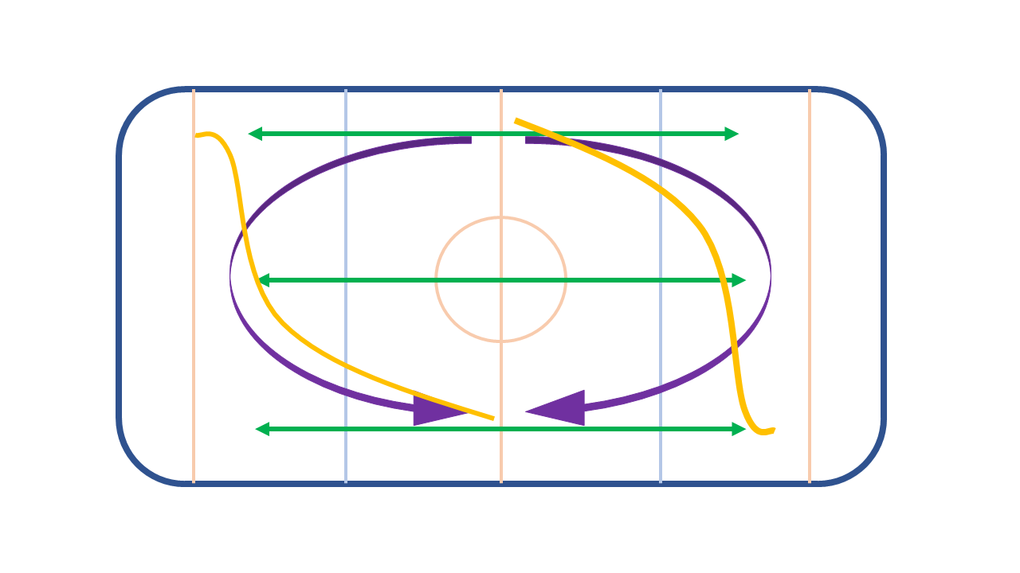
Green
Toe loop
Flip
Orange
Lutz
Purple
3 Jump
Axel
Loop

- Be aware that jump pathways may vary across skaters, it is important to be aware of other skaters at all times while practicing.
- Please ensure that you are aware of your surroundings at all times; when jumping to ensure you are not going to collide with anyone. When choosing a place to spin, keep in mind the jump pathways to ensure you will not impact anyone’s jump.
- Dance programmes may vary in direction (clockwise and anti-clockwise), if you are skating regularly on the same patch sessions please try to familiarise yourself with anyone who is skating a programme.
- Only coaches are allowed to use the music system during patch. Coaches putting the music on for their current lesson have priority. A coach or staff member may at their discretion allow high standard skaters to use the music when it is not busy but coaches still have priority.
- Anyone who wishes to play music and are not in a lesson must ask permission from coaches.
- When entering onto the ice or skating away from the barrier you should check it is safe to do so.
- No eating or chewing gum is permitted on the ice; drinks should be consumed off the ice.
- All spectators (including all parents) should watch from the cafeteria/stands at all times.
- No videos are to be taken unless instructed and authorized by a coach.
- The use of personal music devices is not allowed on patch.
- These rules are subject to change without prior notice and all directions given by ice rink staff or coaches must be followed.
- Off ice training and stretching during patch should be done in the café area, skate hire or around the rink. The clubroom should not be used for off ice training and stretching unless prior permission has been given by a member of the ice rink management team to you or your coach.
How to Dress for Patch
A coach needs to see a skater’s body alignment to give proper advice and feedback about technique, so form-fitting clothing that stretches is better than tight, restrictive or oversized clothes. Sports/skating wear is preferred but jeans are not permitted.
Safety on Patch
Whilst every patch user is responsible for themselves, our coaches and staff will assist in ensuring the patches remain as safe as possible. This can result in them enforcing the patch rules and raising their voices to clearly communicate potential hazards and instructions. ALL patch users must listen to them and follow their directions.

Patch Do’s and Don’ts

Do’s | Don’ts
- Do be aware of other patch users.  - Do keep moving and practicing.  - Do follow the on-ice priority system.  - Do apologise if you get in the way.  - Do as the coaches and staff instruct.  - Do treat the coaches, other patch users and staff with respect.  - Do ask a coach to use the music.  - Do fill up any large holes from your jumps with ice. | - Do not get in the way of patch users in lessons or on the music.  - Do not stand around in corners or by the barriers chatting in groups.  - Do not skate too close to other patch users (including coaches).  - Do not wear headphones.  - Do not kick the ice or barriers.  - Do not take video’s without coaches permission.  - Do not leave holes in the ice.

Charges for Patch
Payment options include: Season tickets or Paying on the day
Standard Patches (pay on day) £7.50*
1 Month Season ticket £85.00*
*Prices are subject to change

Booking your patch ticket online

To encourage speed of service and allow for quicker entry into the rink, patch ice bookings can be done online and in advance before your lesson. This will also ensure that you have reserved a space to practice on patch.

To book online please visit our website www.alexandrapalace.com and locate the ‘learn to skate’ section found under the ice rink tab. This will show you all of our different learn to skate options which includes ‘patch ice’. Open up this tab and it will allow you to book for your chosen date and time.

Once you have booked your ticket, you will receive an email with a QR code that should be presented to the receptionist upon arrival. Please also give them your full name so that we can make note of who attended each patch session.

If you are unsure which levels take place on which session, please see the patch ice timetable. Ensure you are only booking sessions that are appropriate for your level, please read our terms and conditions regarding booking incorrect sessions.

Parents and Carers

We understand that it is important to keep an eye out for your children during their lesson and watching them progress, however we have a few do’s and don’ts for parents and carers.

Do’s | Don’ts
- Do watch from the stands or ice café.  - Do offer encouragement to your child.  - Do speak with the coach for any advice/feedback.  - Do speak with the staff if you have any concerns or questions. | - Do not watch directly from the barrier, this can be off putting and distracting.  - Do not go on the ice with your child without prior permission.  - Do not coach your child unless prior permission has been given.

Attending patch sessions

Patch users under the age of 6 can only be on patch whilst having a lesson with a coach and patch users who are between 6 and 11 should be accompanied by a responsible adult whilst on the premises.

Photography

Photos and videos should not be taken unless authorised by a coach. If you wish to take any photos or videos of your child please avoid getting any other patch users into the photo/video.

Booking lessons with coaches

Booking a private lesson

All private lessons should be booked directly with an Alexandra Palace coach, lessons should also be booked in advance. In order to be signed off for patch ice, you will also have to book a lesson with a coach in order for them to be able to assess your level and sign off the patch registration form.

As all our coaches are self-employed, you must also pay for a patch ice session when having a lesson (this also applies to having lessons on a public session). Please ensure that you have either paid for a ticket online or are ready to purchase a patch ice ticket on the door.

Lessons should not be booked with any coach who is not authorised to teach at Alexandra Palace Ice Rink. All coaches who wish to guest coach or become a permanent coach at Alexandra Palace must get in contact with the Ice Rink Reception. A full list of all Alexandra Palace coaches is available to view on our website.

Cancellation of lessons

Do not book a lesson if you cannot commit to it, please speak with your coach regarding their cancellation and booking policies. If you need your lesson to be moved to another day, please speak with your coach.

If you have booked a patch ice ticket for your lesson, please note that they are non-refundable. If the lesson has been cancelled by a coach and you cannot attend the patch session, please get in contact with the reception team.

If you wish to work with more than one coach or change your coach, please communicate with your current coach to let them know of the change you wish to take place. You must also pay any outstanding debts with your current coach.

Please note that all Alexandra Palace coaches are self employed and Alexandra Palace Ice Rink does not influence any of their prices, booking or cancellation policies. Each coach has individual policies, ensure you have communicated with them and understand what they are and are able to adhere to them.

Coaches

In order for patch to run safely, not only do skaters need to be aware of their surroundings but coaches should be too. When teaching, coaches should try to be at the barrier and at a distance from their pupil unless demonstrating a particular element or movement. This will ensure that jump pathways remain open and other skaters have sufficient space to practice their elements.

Coaches should ensure that their pupils are adhering to the code of conduct and patch etiquette. They are responsible for their pupils and anyone who they have signed off to skate on patch. Please keep this in mind as a skater as inappropriate behaviour will not be tolerated by coaches or Alexandra Palace staff.

All coaches should make pupils aware of their policies around booking or cancelling a lesson and ensure they are understood. This will help ensure that any last minute cancellations are dealt with appropriately and if necessary, action will be taken. Anyone found to be not adhering to coaches policies, can be refused further lessons by that coach.

Any coach who is not an official Alexandra Palace approved coach should not be on the ice or offering any coaching advice to skaters. If you wish to become a coach please get in contact with the ice rink reception for approval or guest coaching. As a pupil, if you would like to have a different coach who is not a part of the Alexandra Palace coaching team, that coach will need to be approved before they can have a lesson with you or attend patch session coaching you off the ice.

Terms & Conditions

It is the members’ responsibility to read and understand the terms, conditions, and rules as set by the ice rink. How they may best be applied within the terms of the membership.

1.0: Patch cards and or a valid receipt must be made available for inspection by any staff member and/or security staff of the Rink whilst in the building. Alexandra Palace Ice Rink reserves the right to refuse admission to a patch or session if you cannot produce a valid Patch Membership card or appropriate receipt and, if requested, some other form of identification. If you cannot produce a valid membership card or receipt, and we are unable to verify your membership entitlement at the time of the incident in question, the Ice Rink reserves the right to refuse admission, or may, at its discretion, offer admission only on the immediate payment of the relevant patch fee or public session entry fee.

  - The Alexandra Palace Ice Rink reserves the right to suspend the use of the relevant membership card of a member and all associated benefits for a period of time or to withdraw their use in the event of misuse or if abused in anyway or in the event of a breach of any of the terms, conditions and rules or in the event of any abusive, dangerous or any other unacceptable behaviour by the member or accompanying associates.

2.0: Nothing in these terms and conditions shall constitute or imply any guarantee of entitlement to ice skate or access to any area of the Alexandra Palace.

  - The Alexandra Palace Ice Rink shall not have any liability to the registered ticket holder in respect of any failure to carry out or delay in carrying out any of its obligations under these terms and conditions, including admitting the member to the Ice Rink for a particular patch or public skating session, caused by fire, flood, accident, strikes or other industrial action, mechanical and/or electrical failure to any plant or systems, refusals to grant any licenses or permissions by the local authorities or any circumstances outside the rink’s reasonable control.

  - No refunds in full or part will be granted throughout the term of the membership due to unforeseen closures and/or failure to provide access to the building for the purpose of ice skating or any other activity associated with ice skating training or ice skating. Patch memberships and sessions are non-refundable.

  - Before booking, check the coaches availability as it is not always possible to exchange and refunds will not be given.

3.0: In the event that your Patch card is lost or stolen the member should report this to the Ice Rink Reception immediately. Duplicate Patch cards (where lost or stolen) are replaceable for a small administrative fee per card.

4.0: Membership Cards and tickets are personal to the member and are not transferable and shall not be transferred under any circumstances. All membership cards and tickets remain the property of the Ice Rink.

5.0: Change of address, eligibility, or personal details as well as any planned non-attendance for specific periods or any lengthy periods of illness or injury must be notified immediately.

6.0: All members must be registered and be having lessons with one of the Alexandra Palace Ice Rink’s fully qualified skating instructors. Patch forms signed off by a coach from a different rink will not be accepted.

6.1: To join a patch session you must be authorised to do so by a skating coach here and be on the correct session for your level of skating. It is the responsibility of the booker to ensure that they have been booked onto the correct session for the skaters level (see timetable) as it may not be possible to exchange and refunds will not be given.

6.2: By purchasing a Patch Membership/Ticket you are agreeing to the Ice Rink’s code of conduct. Failure to follow the code of conduct will result in skaters being asked to leave the ice/memberships being cancelled/ban from future patch sessions. Refunds will not be given.

7.0: If the remittance tendered in payment of a Season Ticket shall be dishonoured or in any other way refused (other than by the Ice Rink), the relevant member shall be liable to pay the Rink's administrative charge and any bank or other similar charge incurred by the Rink as a result.

8.0: None of the terms and conditions, or benefits, of, or under, your membership agreement with the Alexandra Palace Ice Rink are enforceable by any other party.

9.0: Alexandra Palace Ice Rink reserves the right to make changes to these Terms and Conditions, on the giving of reasonable notice, where it reasonably considers it necessary to do so in order for the service it supplies to comply with any changes in the law or regulations applicable there to.

10.0: Any valuables left in the changing rooms or around the rink area are done so at the member’s own risk, Alexandra Palace Ice Rink will not accept liability for any loss, damage or theft of member’s property anywhere in the ice rink.

10.1: The ice rink changing facilities are not currently available. Please arrive at the rink ‘skate ready’.

11.0: The Alexandra Palace Ice Rink reserves the right to refuse any application for membership at its sole discretion without reason.

12.0: The taking of photographs and video motion pictures shall not be permitted without prior consent of the coach/ice rink management.

13.0: No dogs other than guide dogs will be permitted to the Ice Rink without the written consent of the Ice Rink Manager.

14.0: Payment can only be made by, credit card (e.g. Visa, Access, and MasterCard) or debit card (e.g. Switch/Solo/Visa Electron), we do not accept American Express cards.

